



**Semi-Integrated Lights**

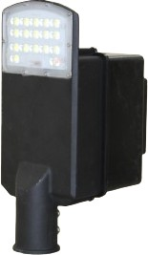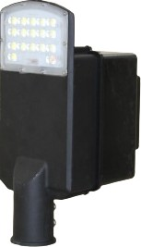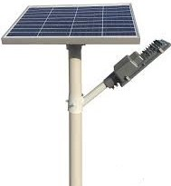

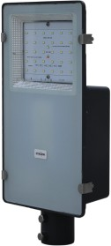

**9W-120W Semi-Integrated Solar Light**

|  |  |  |  |
| --- | --- | --- | --- |
| **Product Code** | **Wattage** | **Battery Details** | **Solar Panel** |
| SMG PR009WSISSTLAH0 | 9W | 12.8V/6Ah LPF | 40W |
| SMG PR012WSISSTLAH0 | 12/15W | 12.8V/12Ah LPF | 50W |
| SMG PR020WSISSTLAH0 | 18/20W | 12.8V/18Ah LPF | 60W |
| SMG PR024WSISSTLAH0 | 24W | 12.8V/18Ah LPF | 80W |
| SMG PR030WSISSTLAH0 | 30W | 12.8V/24Ah LPF | 80W |
| SMG PR040WSISSTLAH0 | 36-40W | 12.8V/36Ah LPF | 100W |
| SMG PR050WSISSTLAH0 | 50W | 12.8V/42Ah LPF | 140W |
| SMG PR060WSISSTLAH0 | 60W | 12.8V/54Ah LPF | 160W |
| SMG PR080WSISSTLAH0 | 80W | 12.8V/72Ah LPF | 180W |
| SMG PR100WSISSTLAH0 | 100W | 12.8V/72Ah LPF | 200W |
| SMG PR120WSISSTLAH0 | 120W | 12.8V/96Ah LPF | 240W |



**Integrated Lights**

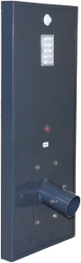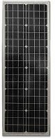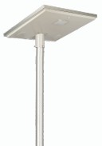

**9W to 100W**

|  |  |  |  |
| --- | --- | --- | --- |
| **Product Code** | **Wattage** | **Battery Details** | **Solar Panel** |
| SMG PR09WISSTLAH000 | 9W | 12.8V/6Ah LPF | 30W |
| SMG PR12WISSTLAH000 | 12W | 12.8V/12Ah LPF | 40W |
| SMG PR15WISSTLAH000 | 15W | 12.8V/12Ah LPF | 40W |
| SMG PR18WISSTLAH000 | 18-20W | 12.8V/18Ah LPF | 50W |
| SMG PR24WISSTLAH000 | 24W | 12.8V/18Ah LPF | 60W |
| SMG PR30WISSTLAH000 | 30W | 12.8V/24Ah LPF | 60W |
| SMG PR40WISSTLAH000 | 40W | 12.8V/36Ah LPF | 80W |
| SMG PR50WISSTLAH000 | 50W | 12.8V/42Ah LPF | 100W |
| SMG PR60WISSTLAH000 | 60W | 12.8V/54Ah LPF | 120W |
| SMG PR80WISSTLAH000 | 80W | 12.8V/72Ah LPF | 160W |
| SMG PR100WISSTLAH00 | 100W | 12.8V/96Ah LPF | 200W |

**High-Mask Solar Lights**

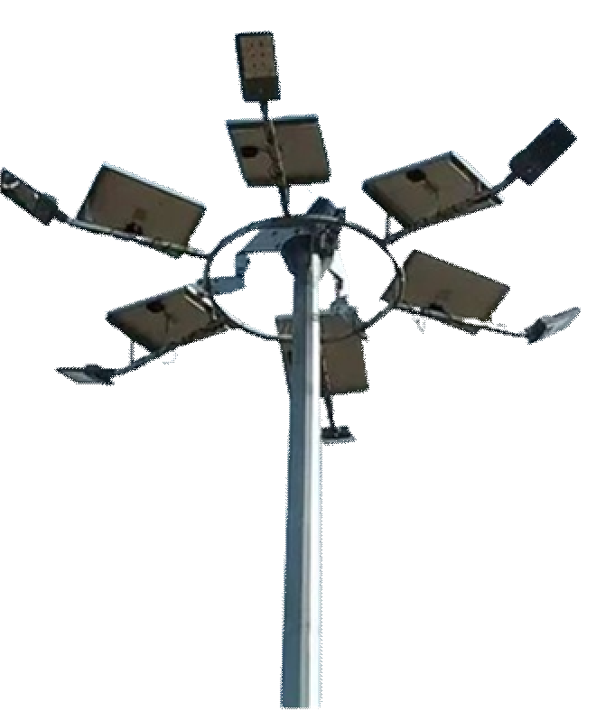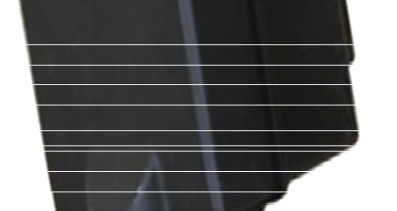

**Flood Light**

**Street Light**

|  |  |  |  |
| --- | --- | --- | --- |
| **Product Code** | **Wattage** | **Battery Details** | **Solar Panel** |
| SMG PR090W | 90W | 25.6V/60Ah LPF | 260W |
| SMG PR120W | 120W | 25.6V/72Ah LPF | 300W |
| SMG PR150W | 75W*2 | 25.6V/84Ah LPF | 400W |
| SMG PR180W | 90W*2 | 25.6V/120Ah LPF | 520W |
| SMG PR200W | 100W*2 | 12.8V/144Ah LPF | 580W |

**Technical Specifications: Solar Light**

* LED Light Lumens: 120/150lm/W.
* BIS Certified Battery- Yes.
* IEC Certified Solar MMPT Charge Controller- Yes.
* MNRE/BIS Approved Mono-crystalline Solar Panel-Yes.
* Charge Time: 5 to 7 Hours Good Sunshine.
* Backup Time: 2 Days autonomy.
* Easy to Install & Ready to use.
* LED Dispersion angle- 120°/145°.
* Light mounting height-4m to 8m above ground depending on LED Wattage.
* Humidity Range-0 to 95% (non-condensing).
* Temperature range-0 to 60 °C.

|  |  |
| --- | --- |
| **LED Indication** | **Condition** |
| RED: Continuous On | Battery full discharged. |
| GREEN: LED Blink | Battery in charging mode. |
| GREEN: Continuous On | Battery fully charged. |

* Solar Charger controller rating -5A/10A/15A/25A.
* LED Driver efficiency- >95% (Battery to Load).
* Battery Reverses Polarity Protection- Yes.
* Solar Panel Reverse Polarity Protection- Yes.
* Load Short Circuit Protection-Yes.
* Battery Low Load Disconnection Yes.
* Battery Full Cut-OFF- Yes.
* Protection Grade (IP)-65- Yes.
* Over Temperature Protection-75- Yes.

**Protections:-**

**Hybrid Solar Inverter**

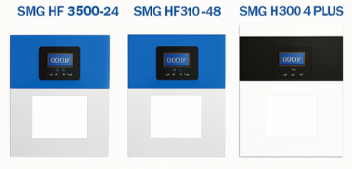

**Features**

**Features**

➢ Single-phase hybrid solar inverter.

➢ Support lithium battery charging and discharging management.

➢ Optional WI-Fl module, supports remote App monitoring.

➢ Highly integrated plug.

➢ Maximum efficiency increased 98.7%.

➢ Seamlessly enable backup power.

➢ Easy to install and maintain.

➢ Support lithium battery adaptive.

➢ 5 years warranty.

* Single-phase hybrid solar inverter.
* Support lithium battery charging and discharging management.
* Optional Wi-Fi module, supports remote App monitoring.
* Highly integrated plug.
* Maximum efficiency increased 98.7%.
* Seamlessly enable backup power.
* Easy to install and maintain.
* Support lithium battery adaptive.
* 5 years warranty.

**Input Parameters**

Voltage : 240V

Frequency : 50/60Hz

Efficiency : 93%

Working Temperature : -10° to 50°C Storage Temperature : -15° to 60°C Communication Interface : RS232/RS485/

CAN / Dry contact

**Output Parameters**

AC Stabilized Voltage : 230V AC (+/-5%) Surge Power : 7KVA/11KVA/16KVA

Switching Time : 10ms for PC / 20ms for Home appliances

Waveform : Pure sine wave

**Technical Parameters**

|  |  |  |  |  |  |  |  |
| --- | --- | --- | --- | --- | --- | --- | --- |
| **Sr.No** | **Model** | **Rated power** | **Max. Photo- voltaic Power** | **Max. PV Open Circuit Voltage** | **MPPT**  **Range & Working Voltage** | **Max. PV charging Current** | **Max. AC Charging Current** |
| 1 | SMG PR HF 3500-  24 | 3500VA  /3500W | 3500W | 500V | 120~450V DC | 100A | 60A |
| 2 | SMG PR HF 5500-  48 | 5500VA  /5500W | 5500W | 500V | 120~450V DC | 100A | 60A |
| 3 | SMG PR HF 8000-  48 Plus | 8000VA  /8000W | 8000W | 500V | 120~450V DC | 120A | 120A |

**Three Phase On‑Grid Inverter Datasheet**

**Three Phase String Inverter**

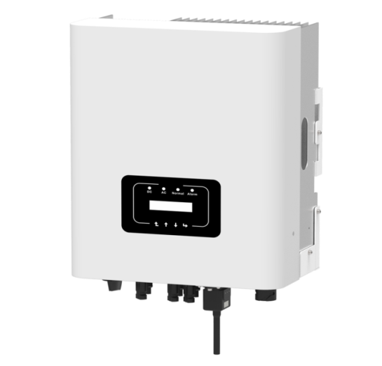

**SMG 5.0K‑3P | SMG 6.0K‑3P | SMG 8.0K‑3P | SMG 10K‑3P | SMG 12K‑3P**

* Zero Export & VSG Application
* Low Start‑Up Volatge of 80V
* Wide Output Voltage Range
* Inbuilt Wifi GPRS (Optional)
* Suited for Outdoor
* BIS Certified 10 Years Warranty
* Easy to Service
* Cloud Based Monitoring

**DC Input**

| **Parameter** | **SMG 5.0K‑3P** | **SMG 6.0K‑3P** | **SMG 8.0K‑3P** | **SMG 10K‑3P** | **SMG 12K‑3P** |
| --- | --- | --- | --- | --- | --- |
| Start up DC Input Voltage(V) | 140 | 250 | 250 | 250 | 250 |
| MPPT Operating Range (v) | 120‑1000 | 200‑1000 | 200‑1000 | 200‑1000 | 200‑1000 |
| MAX. DC Input Power (KW) | 6.5 | 7.8 | 10.4 | 13 | 15.6 |
| MAX. DC Input Voltage (v) | 1100 | 1100 | 1100 | 1100 | 1100 |
| Max DC Input Current (A) | 20+20 | 30+30 | 30+30 | 30+30 | 30+30 |
| Max Short Circuit Current(A) | 20+20 | 30+30 | 30+30 | 30+30 | 30+30 |
| No. of MPP Tracker | 2 | 2 | 2 | 2 | 2 |
| No. of strings per MPP Tracker | 1+1 | 1+1 | 1+1 | 1+1 | 1+1 |

**AC Output**

| **Rated Output Power (KW)** | **5** | **6** | **8** | **10** | **12** |
| --- | --- | --- | --- | --- | --- |
| Max. Active Power (kW) | 5.5 | 6.6 | 8.8 | 11 | 13.2 |
| Rated Ac Gride Output Current | 7.6/7.2 | 9.1/8.7 | 12.1/11.6 | 15.2/14.5 | 18.2/17.4 |
| Max. AC Output Current (A) | 8.3/8 | 10/9.6 | 13.3/12.7 | 16.7/15.9 | 20/19.1 |

* Rated Output Voltage/range (V): 400V AC (3P + N + E)
* Rated Grid Frequency (Hz): 50/60 (optional)
* Operating Phase: Three Phase
* Output Power Factor: 0.8 Leading to 0.8 lagging
* Total Harmonics Current Distortion (THDi): <0.3%
* DC Injection Current (mA): <0.5%
* Grid Frequency Range (Hz): 45‑55

**Efficiency**

* Max. Efﬁciency (Inverter): 98.30%
* Euro Efﬁciency: 97.50%
* MPPT Efﬁciency: >99%

**Protections**

* DC Reverse ‑ Polarity Protection
* AC Short Circuit Protection
* AC Output Overcurrent Protection
* Output Overvoltage Protection
* Insulation Resistance Protection
* Ground Fault Monitoring
* Anti‑Islanding Protection
* Temprature Protection
* Integrated DC Switch
* Remorte Software Upload
* Remorte Change Operating Parameters
* Surge Protection (DC Type II / AC Type II)

**Mechanical & Environmental**

* Size(mm): 330W × 457H × 203D
* Colour Shade: #383636 & #716C
* Weight(kg): 11
* Topology: Transformerless
* Internal Consumption: <1W (Night)
* Operating Temperature: ‑25° to +60° C (derating above 45°)
* Ingress Protection: IP65
* Noise Emission (Typical): ≤30dB Natural Cooling
* Max. Operating Altitude Without Derating: 4000m
* Certiﬁcations: IEC 62116, IEC 61727, IEC60068‑2‑1,2,14,30,27,64, IEC 61683, IEC 61000 1/2, IEC 62109‑1&2
* Humidity: 0‑100% (Non Condensing)
* LCD1602
* RS485/RS232/Wiﬁ/GPRS

**Three Phase String Inverter**

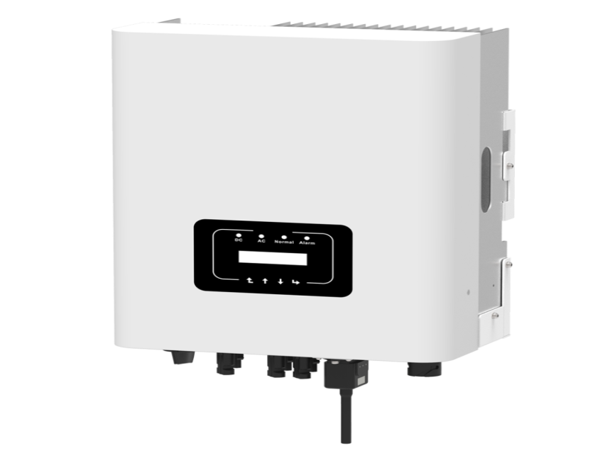

**SMG 15K‑3P | SMG 18K‑3P | SMG 20K‑3P | SMG 25K‑3P**

* Zero Export & VSG Application
* Low Start‑Up Volatge of 80V
* Wide Output Voltage Range
* Inbuilt Wifi GPRS (Optional)
* Suited for Outdoor
* BIS Certified 10 Years Warranty
* Easy to Service
* Cloud Based Monitoring

**DC Input**

| **Parameter** | **SMG 15K‑3P** | **SMG 18K‑3P** | **SMG 20K‑3P** | **SMG 25K‑3P** |
| --- | --- | --- | --- | --- |
| MAX. DC Input Power (KW) | 19.5 | 23.4 | 26 | 32.5 |
| MAX. DC Input Voltage (v) | 1100 | 1100 | 1100 | 1100 |
| Start up DC Input Voltage(V) | 250 | 250 | 250 | 250 |
| MPPT Operating Range (v) | 200‑1000 | 200‑1000 | 200‑1000 | 200‑1000 |
| Max DC Input Current (A) | 20+26 | 26+26 | 26+26 | 26+26 |
| Max Short Circuit Current(A) | 30+39 | 39+39 | 39+39 | 39+39 |
| No. of MPP Tracker | 2 | 2 | 2 | 2 |
| No. of strings per MPP Tracker | 1+2 | 2+2 | 2+2 | 2+2 |

**AC Output**

| **Rated Output Power (KW)** | **15** | **18** | **20** | **25** |
| --- | --- | --- | --- | --- |
| Max. Active Power (kW) | 16.5 | 19.8 | 22 | 27.5 |
| Rated Ac Gride Output Current | 22.7/21.7 | 27.3/26.1 | 30.3/29 | 37.9/36.2 |
| Max. AC Output Current (A) | 25/23.9 | 30/28.7 | 33.3/21.9 | 41.7/39.8 |

* Rated Output Voltage/range (V): 400V AC (3P + N + E)
* Rated Grid Frequency (Hz): 50/60 (optional)
* Operating Phase: Three Phase
* Output Power Factor: 0.8 Leading to 0.8 lagging
* Total Harmonics Current Distortion (THDi): <0.3%
* DC Injection Current (mA): <0.5%
* Grid Frequency Range (Hz): 45‑55

**Efficiency**

| **Parameter** | **Value** |
| --- | --- |
| Max. Efﬁciency (Inverter) | 98.50% / 98.60% |
| Euro Efﬁciency | 97.50% / 97.83% |
| MPPT Efﬁciency | >99% |

**Protections**

* DC Reverse ‑ Polarity Protection
* AC Short Circuit Protection
* AC Output Overcurrent Protection
* Output Overvoltage Protection
* Insulation Resistance Protection
* Ground Fault Monitoring
* Anti‑Islanding Protection
* Temprature Protection
* Integrated DC Switch
* Remorte Software Upload
* Remorte Change Operating Parameters
* Surge Protection (DC Type II / AC Type II)

**Mechanical & Environmental**

* Weight(kg): 15 / 20
* Size(mm): 283W × 463H × 178D / 362W × 527H × 220D
* Colour

**SINGLE PHASE ON‑GRID INVERTER DATASHEET**

**SMG 1.5K‑1P | SMG 2.2K‑1P | SMG 3.0K‑1P | SMG 4.0K‑1P | SMG 5.0K‑1P | SMG 6.0K‑1P**

* BIS Certified – 10 Years Warranty
* Easy to Service
* Cloud Based Monitoring
* Zero Export & VSG Application
* Low Start‑Up Voltage of 80V
* 20A String Current
* Suited for Outdoor
* Wide Output Voltage Range
* Inbuilt Wifi GPRS (Optional)

**Technical Data**

**Input Side**

| **MODEL** | **SMG 1.5K‑1P** | **SMG 2.2K‑1P** | **SMG 3.0K‑1P** | **SMG 4.0K‑1P** | **SMG 5.0K‑1P** | **SMG 6.0K‑1P** |
| --- | --- | --- | --- | --- | --- | --- |
| MAX. DC Input Power (KW) | 2 | 2.9 | 3.9 | 5.2 | 6.5 | 7.8 |
| MAX. DC Input Voltage (V) |  |  | 550 |  |  |  |
| Start up DC Input Voltage (V) |  |  | 80 |  |  |  |
| MPPT Operating Range (V) |  |  | 70‑500 | 70‑500 |  |  |
| MAX DC Input Current (A) |  |  | 20 | 20 |  |  |
| MAX Short Circuit Current (A) |  |  | 30 |  |  |  |
| No. Of MPP Tracker |  |  | 1 |  |  |  |
| No. strings per MPP Tracker |  | 1 |  |  | 2 | 2 |

**Output Side**

| **MODEL** | **SMG 1.5K‑1P** | **SMG 2.2K‑1P** | **SMG 3.0K‑1P** | **SMG 4.0K‑1P** | **SMG 5.0K‑1P** | **SMG 6.0K‑1P** |
| --- | --- | --- | --- | --- | --- | --- |
| Rated Output Power (KW) | 1.5 | 2.2 | 3 | 4 | 5 | 6 |
| MAX. Active Power (KW) | 1.65 | 2.42 | 3.3 | 4.4 | 5.5 | 6.6 |
| Rated Output Voltage/range (V) |  |  | 230V AC (L+N+E) |  |  |  |
| Rated Grid Frequency (Hz) | 50/60 (Optional) | 50/60 (Optional) | 50/60 (Optional) | 50/60 (Optional) |  |  |
| Operating Phase |  |  | Single Phase | Single Phase |  |  |
| Rated Ac Gride Output Current | 6.5 | 9.6 | 13 | 17.4 | 22.8/21.8 | 27.3/26.1 |
| Max. AC Output Current (A) | 7.2 | 10.5 | 14.3 | 19.1 | 25/24 | 30/28.7 |
| Output Power Factor |  |  | 0.8 leading to 0.8 lagging |  |  |  |
| THDi |  |  |  |  |  |  |
| DC Injection Current (mA) |  |  |  |  |  |  |
| Grid Frequency Range (Hz) |  |  | 45‑55 |  |  |  |

**Efficiency**

| **MODEL** | **SMG 1.5K‑1P** | **SMG 2.2K‑1P** | **SMG 3.0K‑1P** | **SMG 4.0K‑1P** | **SMG 5.0K‑1P** | **SMG 6.0K‑1P** |
| --- | --- | --- | --- | --- | --- | --- |
| Max. Efficiency (Inverter) | 97.30% | 97.30% | 97.50% | 97.50% | 97.50% | 97.50% |
| Euro Efficiency | 97.10% | 97.10% | 97.30% | 97.30% |  | 97.00% |
| MPPT Efficiency |  |  | >99% |  |  |  |

**Protections**

* DC Reverse Polarity Protection
* AC Short Circuit Protection
* AC Output Overcurrent Protection
* Output Overvoltage Protection
* Insulation Resistance Protection
* Ground Fault Monitoring
* Anti‑Islanding Protection
* Temprature Protection
* Integrated DC Switch
* Remorte Software Upload
* Remorte Change Operating Parameters
* Surge Protection (DC Type II / AC Type II)

**General Data**

| **Parameter** | **Value** |
| --- | --- |
| Size (mm) | 280W×310H×184D (SMG 1.5–3.0K) / 330W×323H×190D (SMG 4.0–6.0K) |
| Colour Shade | 383636 & 716C |
| Weight (kg) | 4.8 (SMG 2.2K) / 7.7 (SMG 5.0K) |
| Topology | Transformerless |
| Internal Consumption |  |
| Operating Temperature | –25℃ to +60℃ (derating above 45°) |
| Ingress Protection | IP65 |
| Noise Emission (Typical) | ≤35dB |
| Cooling Type | Natural Cooling |
| Max. Operating Altitude Without Derating | 2000m (SMG 2.2K) / 3000m (SMG 5.0K) |
| Certifications | IEC 62116, IEC 61727, IEC60068‑2‑1,2,14,30,27,64, IEC 61683, IEC 61000 1/2, IEC 62109‑1&2 |
| Humidity | 0–100% (Non Condensing) |
| Display | LCD1602 |
| Interface | RS485 / RS232 / Wifi / GPRS |



* **25/2, R.K.Layout, 16Th Main ,5Th Cross, R.K layout,Padmanabhanagar-Bangalore -560070,**

[**https://www.smgpowersolution.com**](https://www.smgpowersolution.com)



smgpowersolution@zohomail.in



**+91 7892903806, +91 7204523401**